# Student Information

**NAME** **:** Deepesh Patil

**MIS :**  112215055

**Group :** 2

## **ASSIGNMENT-1 Outputs**

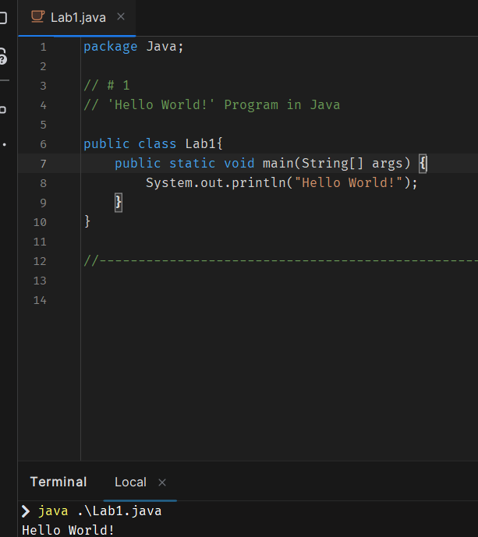

## **Assignemnt-2 Outputs**

### Exercise-1

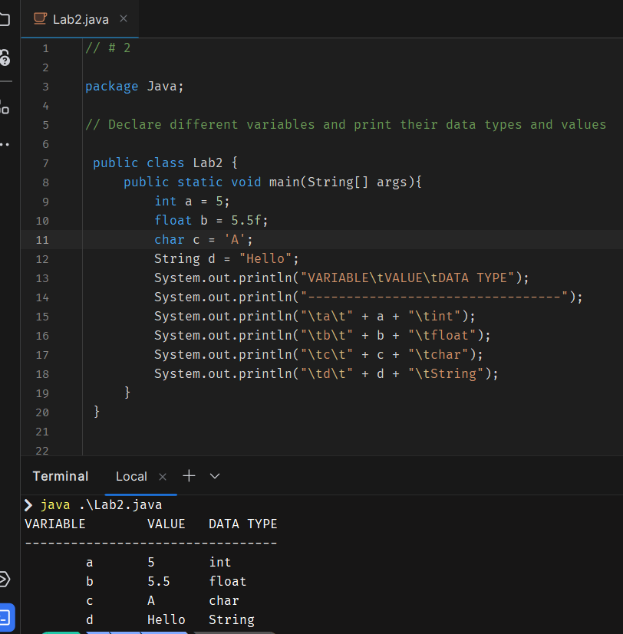

### Exercise-2

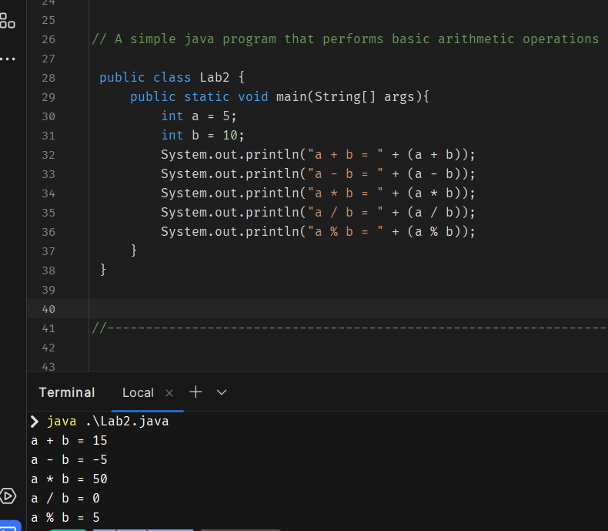

### Exercise-3

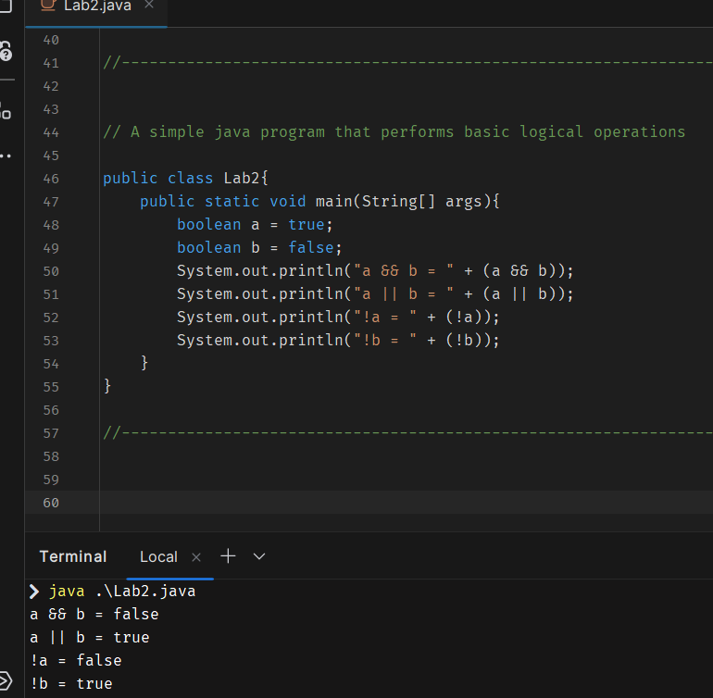

## **ASSIGNMENT-3 Outputs**

### Exercise-1:

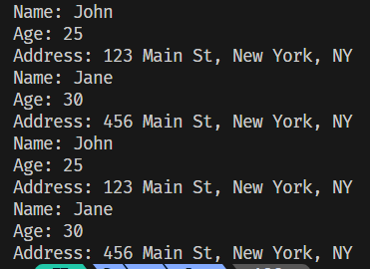

### Exercise-2:

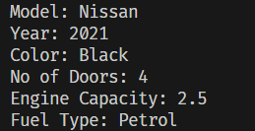

### Exercise-3:

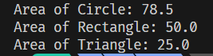

### Exercise-4:

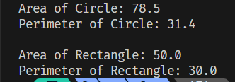

### Exercise-5:

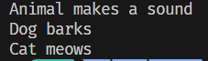

## **ASSIGNMENT-4 OUTPUT:**

### Exercise-1: Exercise-2:

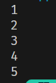 

### Exercise-3:



## **ASSIGNMENT-5 OUTPUT:**

### Exercise-1

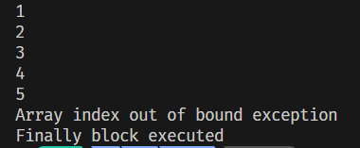

### Exercise-2



## **ASSIGNMENT-6 Output:**

### Exercise-1



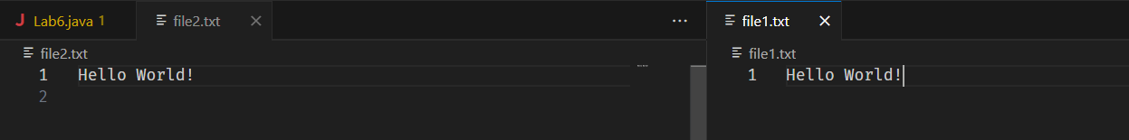

### Exercise-2

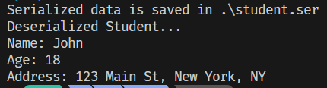

## **ASSIGNMENT-7 OUTPUTS:**

### Exercise-1 Exercise-2

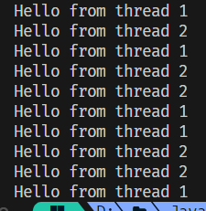 

## **ASSIGNMENTS-8 OUTPUTS:**

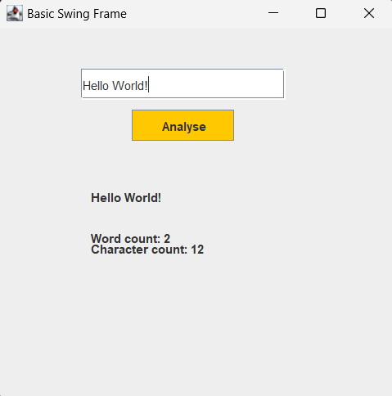

## **ASSIGNEMNT-9 OUTPUT:**

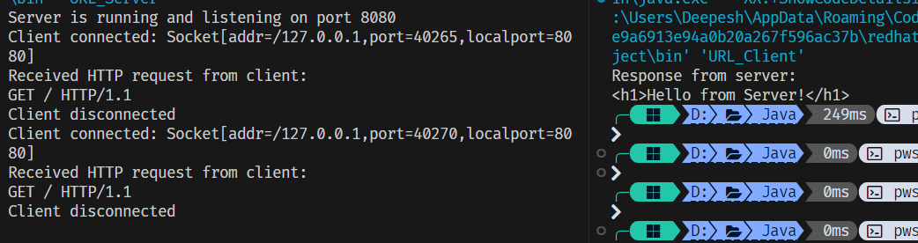

## **ASSIGNMENT-10 & 11 OUTPUT:**

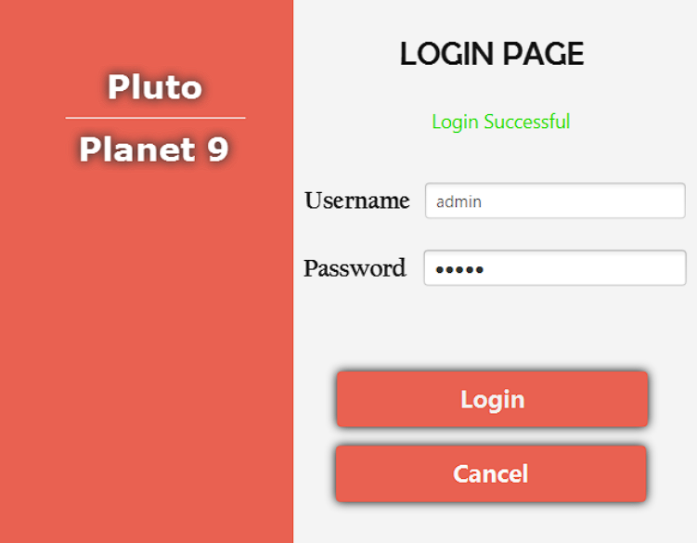

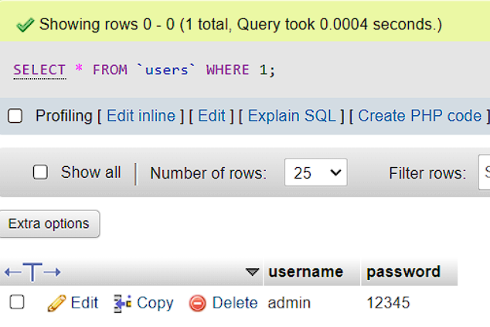

## **ASSIGNMENT-12 OUTPUT;**

